FRANK ALFANO OVERTIME AWARD

Overview
The San Diego County Football Officials Association’s “Frank Alfano Overtime Award” is presented to an active or associate member that exemplifies merit and achievement both on and off the football field. Frank Alfano was a long-time member of our Association and was passionate in his avocation. He served as a Captain on the San Diego Fire Department and battled cancer for several years before finally succumbing to the disease.
The award is presented by the Board of Directors annually and offered to the San Diego County Sports Officials’ Hall of Fame for consideration. Examples of qualifications are…military service, public health and safety service, members who have been challenged with health or family concerns and have overcome to succeed, members who have been involved with community outreach programs, or members who have made a significant contribution to our community through their voluntary or philanthropic endeavors.
This recognition is granted to the member who works “overtime” to be proficient in their avocation as well as their vocation. This member positively represents our Association both on and off the field.
As football officials, we all understand sacrifice, perseverance, and teamwork. The “Frank Alfano Overtime Award” is the Association’s recognition of how an individual’s officiating and community involvement can make a difference in the effort to expand opportunities now and in the future.

Selection Criteria
- Recipient shall be an active certified member of the SDCFOA for a minimum of three years or shall have been an active certified member of the SDCFOA for a minimum of three years (associate member).
- Consideration given to level or participation within the SDCFOA.
- Strong consideration given to reputation in the San Diego County football community.
- Award may not be given to a prior recipient.
- Award may or may not be given each year.

Selection Committee
- The selection committee shall serve the SDCFOA Board of Directors (BOD) as an ad hoc committee.
- The committee shall be responsible for the following general tasks.
  - To develop and maintain the administration of the Frank Alfano Overtime Award for the SDCFOA.
  - To annually select up to three nominees for the award. A member’s selection as a nominee for the award shall be based on standards and criteria approved by the BOD (see Overview and Selection Criteria above).
  - To formally present the ranked list of nominee(s) for the award to the BOD and obtain approval of the final winner.
- The committee shall consist of three certified members (active or associate) of the SDCFOA.
- The committee shall be Chaired by a certified member (active or associate) of the SDCFOA and the Chairman shall be appointed by the sitting Association President each year. The Chairman shall then be presented to the BOD for approval. There is no term limit for the Chairman of the committee.
- The Chairman shall retain or recruit two additional certified members (active or associate) of the SDCFOA to serve as committee members. These committee members shall be appointed by the Chairman each year.
The appointees shall then be presented to the BOD for approval. There is no term limit for members of the committee.

Procedure for SDCFOA President
• The sitting President of the SDCFOA shall be responsible for the following tasks related to the Frank Alfano Overtime Award.
- Retain or appoint a Chairman of the award for the calendar year he presides. He should conduct this business before the February BOD meeting and present his selection at the February BOD meeting. The selection of the award Chairman requires BOD approval.
- In the event the President’s Chairman selection is not approved, the President shall be responsible for selecting a qualified and eligible alternative member.
- The President shall be present and assist in the presentation of the Overtime Service Award at the Association’s annual banquet in November.

Procedure for SDCFOA Board of Directors
• Sitting members of the SDCFOA BOD shall be responsible for the following tasks related to the Frank Alfano Overtime Award.
- Approve a Chairman for the award as appointed by the President. This is usually done at the February BOD meeting.
- Approve an alternate Chairman for the award appointed by the President if the President’s original selection is not approved by the BOD.
- Approve two committee members appointed by the Chairman. This is usually done at the February BOD meeting.
- Select an annual winner for the Frank Alfano Overtime Award based on the findings of the award committee and recommended by its Chairman. This is normally done while in executive session at the September BOD meeting.
- Select a winner for the Frank Alfano Overtime Award based on the findings of the award committee and proposed by the Chairman if one or more of the Chairman’s original selections is not approved by the BOD (September meeting executive session).
- Select no winner for the Frank Alfano Overtime Award for a given year if no proposed candidate receives BOD approval (September meeting-executive session).
- Select and allocate funds for an actual award to be presented to the Frank Alfano Overtime Award winner. This is normally done at the September BOD meeting.

Procedure for the Committee Chairman
- Retain or appoint two eligible committee members to serve for the pending SDCFOA season. This is normally done before the February BOD meeting.
- Ensure that the Committee Chairman and two appointed committee members were approved by the BOD.
- Provide an annual status report at the March or April BOD meeting.
- Ensure that the process used to administer the award complies with the procedures outlined in this document as approved by the BOD for the SDCFOA.
- Organize, maintain and secure member surveys.
- Maintain and secure a list of nominated candidates.
- Using the “General Procedures” below and working with the other committee members, determine and rank three top nominees to be selected for the Frank Alfano Overtime Award.
- Formally recommend the top final nominee to the BOD. This is normally done at the September BOD meeting while in executive session.
- If for whatever reason the top final nominee is not approved by the BOD, recommend the second or third ranking nominee. If the BOD does not approve one of the three nominees, no award will be given that year.
- Secure funding for the actual award through the BOD. This is normally done at the September BOD meeting.
- Ensure that an actual award is prepared for presentation.
- Present the Frank Alfano Overtime Award to the eventual winner. This is normally done at the November SDCFOA banquet. Request that the sitting SDCFOA President is present during the presentation.
- Maintain a list of SDCFOA members who receive the Overtime Service Award for historical purposes. Include the year the member received the award.

Procedure for the Committee Members
- Use the “General Procedures” below and work with the other committee members to effectively administer the Frank Alfano Overtime Award as approved by the SDCFOA BOD.
- Complete other tasks as directed by the Chairman of the committee.

General Procedures
- The committee will conduct an informal survey of all SDCFOA members via the Association Website. The survey allows our members to convey the many contributions they make to our local community and the country. It will also assist the award committee in assessing our member’s external community involvement.
- Surveys can be completed and submitted by SDCFOA members at any time.

SURVEY SAMPLE
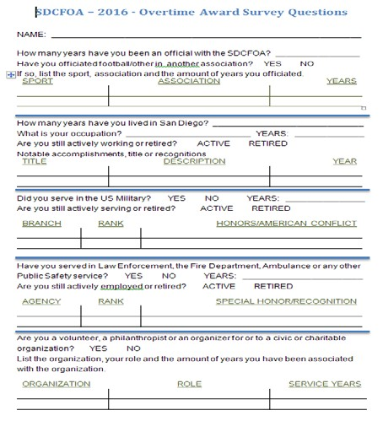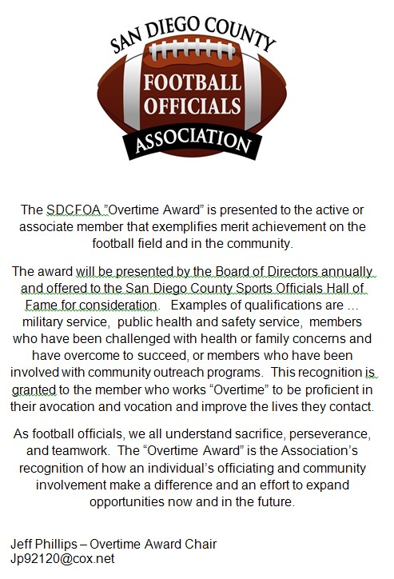

- A member of the award committee shall address the entire membership at the July “First General Meeting” every year. This brief address should cover the following points.
  - A brief explanation of the Frank Alfano Overtime Award.
  - Eligibility to receive the award.
  - Who can nominate a member for the award.
  - How to nominate a member for the award.
  - Encourage members to fill out a survey via the Association website if they have not done so already.
  - Encourage members to submit an updated survey if they wish.
- The award committee shall accept nominations for eligible members of the Association. The deadline for nominations will be August 31st of each year.
Nomination Criteria
  - Nominations can be made by active, associate, and retired members of the SDCFOA.
  - Nominations can be made by individuals active in San Diego County football (HS and youth coaches, AD’s, CIF, etc.).
  - Self-nominations are welcome and encouraged.
- After the deadline for nominee submissions has closed for a given year, each member of the award committee shall review all member surveys and all nominations submitted. They should determine and rank their own list of candidates without influence from the other committee members. Top (non-winning) candidates from the previous year(s) are given strong consideration. When the three committee members have completed their review, they shall meet or phone conference to discuss and rank three top final candidates for the award.
- The Chairman shall attend the September BOD meeting to formally recommend the top ranked nominee for award selection. A winner of the award requires approval by the BOD.
- If, for whatever reason, the BOD does not approve the committee’s top ranked selection, the second and third ranked selected can be presented for approval by the BOD.
- The Chairman should request funding for the actual award from the BOD. This is also done at the September BOD meeting.
- Once the BOD has approved a nominee for selection of the award, the Chairman shall task a committee member with arranging for and securing an actual award for presentation at the annual November banquet.
- At least two weeks before the annual November banquet, the committee Chairman should contact the award winner to notify him or her that they will be presented the award at the banquet. This will allow the recipient time to prepare a brief speech in acceptance of the award.
- At the annual November banquet, the Frank Alfano Overtime Award shall be presented to the winning member by the Chairman. The Chairman shall address the membership and provide the details that merit the award winner’s selection. The Chairman shall then call on the winner to enter the stage and receive his award. The sitting President of the Association shall also be present on the stage during this presentation.

