San Diego County Football Officials Weekly Bull 12-17-20

- On Monday, December 14, the California Department of Public Health released guidelines related to Outdoor and Indoor Youth and Recreational Adult Sports.

- “Inter-team competitions (i.e., between two teams) will not be allowed in California until January 25, 2021, at the earliest, based on the guidelines outlined in this document. The return-to-competition date will be reassessed by January 4, 2021 based on California disease transmission trends and is subject to change at any time given the level of COVID-19 transmission in California.” – CDPH

- Monday, January 4 – The California Department of Public Health will reassess the January 25, 2021 return to competition date and evaluate the situation at that time.

- Tuesday, January 19 – CIF Section Commissioners are planning to provide an update on the plans for Fall Sports and Championships.

- “It is important to note that what was recommended by our CIF Sports Medicine Advisory Committee is not what we see here. We requested that all sports be conducted in the Red Tier and were hopeful that we would be allowed to proceed accordingly. While that is not the case today, I want to assure you that the dialogue will continue between the CIF and the California Department of Public Health to try and advocate for the return of education-based athletics as soon as that can happen in a healthy and safe way.” – Rob Wigod, CIF Southern Section Commissioner

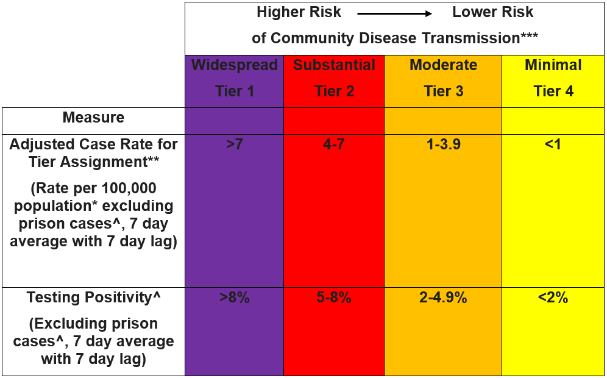

Table: Youth and Adult Recreational Sports* Permitted by Current Tier of County

(Purple)

Outdoor low-contact sports

Badminton

Cross country

Golf

Physical training

Swimming and diving

Tennis

Track and field

(Red)

Outdoor moderate-contact sports

Baseball

Cheerleading

Field hockey

Lacrosse (girls/women)

Softball

(Orange)

Outdoor high-contact sports

Football

Ice hockey

Lacrosse

Soccer

Volleyball

Water polo

Indoor low-contact sports

Badminton

Dance

Gymnastics

Physical training

Volleyball

(Yellow)

Indoor moderate-contact sports

Cheerleading

Indoor high-contact sports

Basketball

Ice hockey

Soccer

Water polo

Wrestling

To advance:
- A county must have been in the current tier for a minimum of three weeks.
- A county must meet criteria for the next less restrictive tier for both measures for the prior two consecutive weeks in order to progress to the next tier.
- In addition, counties must meet the health equity criteria to demonstrate the county’s ability to address the most impacted communities within a county.
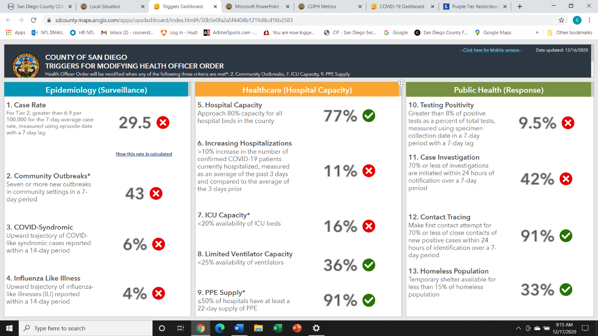
CIF 2020-21 Football Guidelines & Covid-19 Modifications
General Guidelines
• Masks shall be worn at all times by all individuals in attendance other than when engaged in competition.
• Social distancing measures shall be in place at all times other than when engaged in competition.
Event Limitations
• 10 games permitted during the season.
• Adhere to local county guidelines.
Pre-Game Conference
• Limit attendees to one captain from each team, Head referee and Umpire.
• Coin toss should take place in the center of the field with designated individuals maintaining social distancing of 6-feet.
• No handshakes prior to and following the coin toss.
• Maintain social distancing of 6 feet while performing all pregame responsibilities with all officiating crew members, game administration staff, line-to-gain crew, clock operators, individuals handling the balls during the game and team personnel.
Team Benches
• The team box may be extended on both sides of the field to the 10-yard lines (for players only) in order for more social-distancing space for the teams.
• Maintain social distancing of 6-feet at all times while in the team box.
Pre/Post-Game Ceremony
Replace handshakes after the game with a social distance acknowledgment of the team’s choosing.
Football Sanitation
Games shall utilize a three-ball rotation, ensuring that anytime a ball goes out of play it shall be sanitized thoroughly with a bleach wipe before returning to the rotation.
Equipment & Accessories
• Permissible face coverings are required to be worn at all times by all attendees present.
• Gloves are permissible.
• Players shall utilize their own equipment bin for all personal gear on the sideline.
Water Bottles & Hydration Stations
• Team members shall not share water bottles.
• Hydration stations may be utilized but shall be touched only by a single appointed monitor. Officials’
Uniform & Equipment
• By local association adoption, long-sleeved shirts are encouraged.
• Do not share uniforms, towels and other apparel and equipment
• Permissible face coverings are required.
• Gloves are permissible.

