New Members Guide

2022

www.sdcfoa.org

Introduction
We are excited that you have decided to join SDCFOA, and we look forward to helping you develop as a football official.

Football officiating is a challenging advocation, but there are great rewards. To be a successful official, you will need mental toughness, good people skills and thick skin. Football officiating will inherently teach you all those skills and much more. More importantly, officiating will teach you how to view the games in a whole new light. Get ready to challenge yourself and start one of the most rewarding advocation you will ever have!

The first-year instructional program is to help you build your knowledge of the rules and mechanics necessary to put yourself in position to make the right calls. We hope that instructional program will move you along so that the game slows down and you become more comfortable and proficient at officiating.

The following pages are to help and guide you through the program. Please let us know what we can do to help and best of luck in your development.

We look forward to getting to know you and are excited about serving as your guides on the road to becoming a football official. All pages can be found on the website and Mechanics Manual.

Most importantly, HAVE FUN!

If you have any questions, please contact:

Gary Gittelson at (619) 431-0459
recruiting@sdcfoa.org

The SDCFOA Recruitment and Retention Committee

Table of Contents
Introduction 2
Becoming an Official 4
San Diego County Football Officials Association 5
Registration and Dues 6
Transfer Officials 6
Retired Military 6
Game Fees 8
Instructional Packet 8
Website 9
Instructors 10
Meetings 10
Training 11
Time Commitment 11
Uniform and Equipment 12
Assignments 17
Scrimmages 18
My First Assignment 18
Advancement 19
Expectations and Tips for New Officials 20
Useful Links 22

Becoming a Football Official
Welcome to the San Diego County Football Officials Association and your desire to become a football official. Our association is credited with some of the finest officials at the youth, High School, College and NFL levels. Membership shall be available to any person interested in football officiating provided he/she fulfills the requirements of membership and has complied with the ethical standards of the Association. No athletic background or football experience is needed. You must be 18 years old or older by August 1st of application year. While it will help if you have some general knowledge of the game, you will receive training throughout the year.
The association is comprised over 200 individuals throughout San Diego County, businessmen, school administrators, professionals, civil service, retired/active military and more. They come together for:
- Love of the game!
If you love football, officiating is the greatest way to stay involved in the game. Each official is actively involved in every play of the game. It is an exciting opportunity and an enormous responsibility. The great thing about becoming a football official is that you get to be on the eld, instead of watching from the sidelines.
- For the money
Football officiating is not an extremely lucrative hobby, but you will see a positive cash flow. Unlike other hobbies, the time spent officiating will put some money in your pocket.
- Make Great Lifelong Friends
Football officiating is like a fraternity, and your fellow officials can become your friends for life. A tremendous bond is developed between officials as they work together for the common good and compete alongside each other on the field. It's a special bond that is created and it can only be fully explained after you've experienced it.
- Great Way to Stay in Shape
Officiating provides a meaningful reason to stay in shape. As we get older, many adults find it more difficult to find the time to exercise. Officiating gives you the opportunity to get out of the house two or three times a week. The successful official is motivated to exercise year-round.
- Be a positive role model.
Officiating provides a unique opportunity to influence young people positively. A football official is a role model who is in charge with enforcing the concepts of fair play and good sportsmanship.
Each official began their career in instructional classes and on field training with other beginners lead by seasoned and experienced instructors. Each year thereafter further class participation and on field training they – have honed these skills in the rules and game mechanics. However high we each may rise in the ranks of football officiating we all started and continue to work Saturday morning Pop Warner assignments.

Our Association, the San Diego County Football Officials Association (SDCFOA), is responsible for the assignment of football officials for virtually all football games played throughout the county, from Pop Warner to High School Varsity. We are constantly in need of dedicated men and women who are willing to become trained and qualified football officials.

Some of our members are NCAA certified and work various college games, from the Community College level all the way up to Division I. We hope that you decide to join us and share our passion for this great game of football and for the young athletes of San Diego County.

San Diego County Football Officials Association
The San Diego County Athletic Officials Association was created in 1915 to provide officials for High School and small College sports. The Association would later break up into individual Associations for each sport, creating the San Diego County Football Officials Association.
For several years, the SDCFOA was affiliated with the Southern California Football Officials Association for Instructional Program purposes. In 1960, it was felt that the Instructional Program might be better organized and conducted if it were handled locally. It would also be financially beneficial since SDCFOA was paying SCFOA for materials.
In 1974, the Board of Directors decided to form crews for Varsity games. For the first few years, the crews were assigned by a committee of the Board and then the concept for a draft came about. Every June a draft is held with each crew chief selecting his own 5-man crew for that year.
Over the years we have had 8 members that went on to work in the NFL, with over 25 in Division I and several others currently working Division III and Jr. College football.
Association membership has grown over the years from roughly 100 in the mid-70s to the approximately 300 we have now. We have grown into 36 crews and now service 100+ High Schools.

President: Terry Bernard
Executive Secretary: Ed Zapolski
Treasurer: Terry Thompson
Instructional Chairman: Steve Coover
CIF Liaison: Steve Coover
Ratings Chairman: Bob Duggan
High School Assigner: Tom Ables
Youth Assigner: Brad Cowan
Youth Assigner: Bob Duggan
Banquet Chairman: Bob Hood

Board of Directors: Bob Flavin, Brandon Chavez, Zack Marble, Dave Garza, Brian Mills, Ted Schiess, Scott Carroll, Kevin Haws, Matt Starr, Rob Schaerer, David Middleton and Charlton Lynch.

Registration and Dues
To become an Official in the San Diego County Football Officials Association (SDCFOA) you must Register on-line and pay your dues. You will be required to pay your dues. Your dues include instructional materials, assignment secretaries’ fees and banquet.

First Year Officials is $99 by mail or $99.00 + $5 service fee on-line.
Transferring Officials dues will be set in February pending board approval.

There are 2 ways you may pay for your dues:
1) You may register by either sending a check or money order payable to SDCFOA and include a signed Release Form, to SDCFOA c/o Treasurer, 952 Bittersweet Street, Escondido, CA 92026.
2) You can register online via PayPal and pay with a credit card ($5 service fee will be added) using the form online.

Transfer Officials
Those transferring into our Association, will need to provide a transfer letter with information from your previous Association that includes how long you worked, levels worked, and ratings. You will be placed in the second-year class and evaluated by the Assigner to determine game assignments.

Retired Military
On behalf of the SDCFOA, and our families, we want to thank you for your service!

Battlefields 2 Ballfields, also called B2B, provides military veterans an opportunity to participate with their communities through our Sports Officiating Scholarships. This program was founded in 2017 and is still run by Mike Pereira. Serving in the military, and in officiating, there is a common bond of being a member of a team and creating order out of chaos. B2B provides veterans with an opportunity to use their newfound officiating skills while participating in something that will give them a sense of Youth Sports involvement and earning a little extra money.

B2B will pay for the uniforms and dues associated with the veteran who is starting out with our Association for up to three years. This program also includes training materials, insurance, and a subscription to Referee Magazine.

The partnership between B2B and the San Diego County Football Officials Association remains one of the strongest in the country!

Welcome to this special program as we are honored to provide it to our current and retired veterans.

For additional information please reach out to the San Diego County B2B representatives:
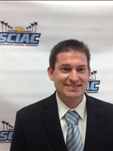  Tyler Lindsay  (619) 672-6837 |  | 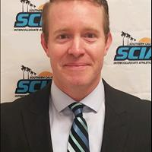  Joe Magnuson  (760) 504-6934

Uniforms and Equipment
The cost can range from $99.00 to $200.00 for startup packages depending on your preferences. Normally the first two weeks will cover any costs for Uniform and Equipment.

Insurance
The official, independent of the Association, must obtain insurance for liability and medical coverage. As independent contractors, all officials will be required to sign a waiver indicating that they are currently covered by a medical policy, or, if not, that they understand any injury incurred while officiating or traveling to or from officiating is their own responsibility.

Liability insurance may be purchased through any one of several agencies, such as the National Federation of High Schools or the National Association of Sports Officials, offer liability coverage with many other membership benefits for joining their organization.

Helpful links for Insurance

National Federation of State High School Associations - Dissinger Reed |  | Insurance - National Association of Sports Officials (naso.org)

Game Fees
Youth Football pays from $66.00 per game, High School Freshman/JV games at $72.00, Referees $73.00 and Varsity at $83.00 Referees $85.00.
No mileage allowance.

How Do I Get Paid?
Youth Football: Most sites ask that you sign in before your first game. During halftime of your last game, go to the appropriate person for payment. Some pay by check and some pay in cash. For most leagues, if you get a check, cash it as soon as possible.

High School: Some pay by check on the field, RefPay and others pay by mail. Most schools have you sign a pay sheet, you will then receive a check from the school within two weeks. Delay in payments may occur if it involves a year-round school or a game that is worked near a holiday.

Instructional Packet
Depending on when you have completed registration and have paid your dues, the instructional packet will be available at the first general meeting. If you register late a packet will be made and available, at the next meeting. The first meeting is usually on Wednesday after the Fourth of July week. Copies of study guides, tests, and mechanics manual available on the website. The following items are included in your instructional packet:
Rulebook
- All new members will receive a hardcopy of the NFHS rulebook. There is no PDF available for this book.
Casebook
- All new members will receive a hardcopy of the NFHS casebook. There is no PDF available for this book.
Study Guides
- Two sets of study guides will be available one for rules and on for mechanics. It is good to go over these as some test questions come directly off these guides.
Tests
- Tests from the NFHS Part 1may also be included. Working rules tests are an excellent way of improving your rules knowledge.
Mechanics Manual
- A Mechanics Manual will be included. In 2018, we started publishing the Mechanics Manual. It will be reprinted every other year. The manual includes 3, 4, & 5 man mechanics and information regarding the association and advancements. It also includes instruction for chain crews and clock operators.
Classroom Assignments
- It will show your room number and your instructors. Classroom assignments available on the website.
Meeting Schedule
- An updated meeting schedule. Meeting Schedule available on the website.
Weekly Bull
- Contains useful information regarding the upcoming season, any changes and rule clarifications.

Website
The website has been updated and contains numerous handouts, study guides and additional information regarding the SDCFOA.

Weekly Bulls
Bulletins sent to officials weekly during the season. Updates rules, issues that come out, Food for Thoughts and rule questions. Older Weekly Bulls will be available.

Calendar and Announcements
A place where all scheduled meetings and all e-mails are posted.

Video
Great source of regarding mechanics and judgement calls. Additional videos will be added to the library. All 11-man football games that we work are available for viewing with the individual crews. Plays are selected by Instructional Chair to assist the association to be more consistent with our decision making.

Rules and Mechanics
New rules and 3-to-5-man mechanics are available for viewing. Additional information regarding chain crew and clock operators’ instructions are available.

Study Guides
Study guides is a good source to prepare for tests.

Handouts
Handouts from various clinics and officials that are giving back and sharing their experiences.

First Year Instructors
Earl Totty | Gary Gittelson | Tom Ables

Second Year/Transfer Instructors
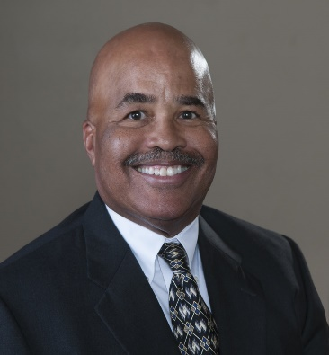  Don Carey | Ed Blick | Jimmy Christensen

Meetings
First year and transfer officials’ meetings are provided each season. These meetings are typically scheduled from 7:00pm to 8:30pm on Wednesday evenings. The meetings are designed for the benefit of the officials and are an invaluable source of education and training at all levels. The location and time of the meetings will be posted on the SDCFOA website (www.sdcfoa.org) so please check the website regularly to get the latest information. Attend the meetings as often as you can.

We begin our meetings in July, and you will receive training and instruction from some of the finest officials in the county with over 150 years of experience. These dedicated officials will teach you at a pace you can easily understand. When your games start you will be assigned with experienced officials who will enhance your training experience. You will learn the fundamentals of officiating and will have the chance to progress at your own pace. Each week you will have the opportunity to discuss your games with the instructors and your fellow first year officials.

Training
Our association provides officials for various youth football games as well as all the high schools throughout the county. You may be given the opportunity to work with the crew as a chain crew member or clock operator on varsity games. You are welcome to join in on the pre- and post-game discussions. These will provide great experiences and will only enhance your growth as an official. These are excellent tools to help you in enhancing your own officiating skills. The SDCFOA, provides a training program for new and returning members. Training includes classroom and on- field training is taught by veteran officials. Our initial focus for first-year officials is on mechanics. We will explain what to do and then why you do it.

Football requires officials to work at different positions around the playing field, each responsible for watching a different part of the action. To maximize your success, you will have to learn several of these positions well. Football officials work with more partners than most other sports, so depending on what position you are working during a game, you will have different responsibilities. Being able to change focus and remember different rules and mechanics for each different position you may work is important. Teamwork is vital in football and your ability to work with and get along with others and take direction from your crew chief is vital to your success. You are required to attend meetings take a rules and mechanics test with a minimum passing score, and payment of fees for the upcoming season.

Time Commitment
A certain amount of dedication and time is required to not only to improve our skills as officials, but to provide and assure quality officiating to the schools and organizations we serve. Your commitment to continued improvement in your knowledge of the rules and mechanics, along with the same commitment to maintain a high level of physical fitness and presence, will make you personally better and our association stronger.

You must be prepared to commit 2-3 nights per week during the period July through November for meetings and game assignments. There is usually a training meeting on Tuesday, junior varsity games on Wednesday and Thursday, varsity games on Friday and sometimes Saturday afternoon. Although you are not required to be available all of these times every week, the season is short, less than 3 months, and the greater the availability, the greater the experience. To qualify as an official, you need to attend a certain number of meetings and need to pass a rules and mechanics examination each year. These are both scheduled in the August-September time frame and are mandatory to be eligible for the crew draft. The freshman and JV games begin around 3:00 pm or 5:00pm and each game will be 1-1/2 to 2 hours. As a first-year official, you can work games, and you’ll decide how much you want to work depending on your desire and availability and the number of game assignments that are available.

Uniform & Equipment
Uniform
Officials shall purchase and maintain their uniforms and equipment. Officials will be required to wear the uniform as indicated. Uniform, including shoes, should appear clean. Assigned Referee or Crew Chief notifies the crew of the option. ALL must be uniform.

- Shirts: Black and white vertically striped (2 ¼”), short and long sleeve knit shirt or micro-mesh shirt with black knit cuff and collar. An American Flag (3 ½” by 2”) shall be imprinted or sewed on to the shirt ½” above the pocket.
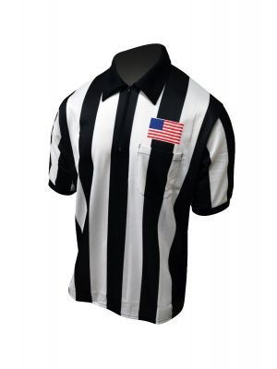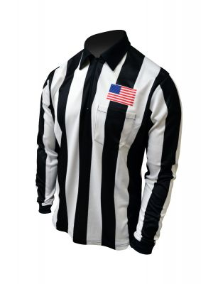

- Pants: The pants shall be full length black pants. The pants must include a one and one quarter inch white strip on the seam of the leg, must not be cuffed, and must continue to the shoe without a break. Pant length may need to be tailored. A High School crew must wear the NFHS black with white stripes uniform pants at all levels.

- Black football cap (fitted) with white piping. Referees wear solid white baseball cap. Micro-mesh caps may be used at all levels.
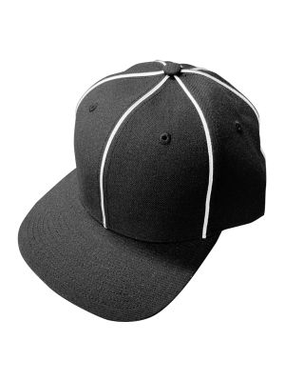
- T-shirts and turtlenecks (for cold weather games) should be black with no letters or photos that may be seen through uniform.

- All black belt with non-descript buckle. Belt must also be worn with shorts.

- All black shorts may be worn for youth games. They may not be worn on or after November 1st or any youth playoff games.

- Black crew length or longer socks must be worn with the pants.

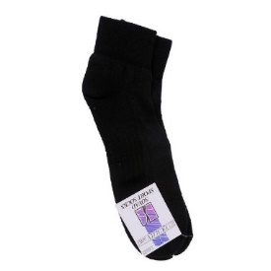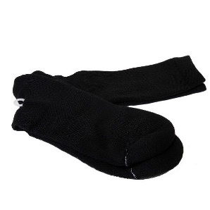

- Black football shoes with black shoelaces. (Shoes may have some white markings)
- Wristwatch with countdown timer.

- All-black frame "Running" or "Triathlon" style Sunglasses or photo gray lenses may be worn when working any daytime football game.
- No jewelry. (Wedding rings and medical alert bracelets are an exception)

Equipment
The following equipment is required to be carried by all game officials, unless noted by position. Should have back-up whistle, flag, chain clip and down markers.

- Whistle (Fox 40) with all black lanyard or finger whistle

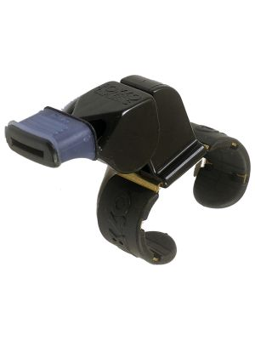

- Black lanyard. Multiple Styles are available.

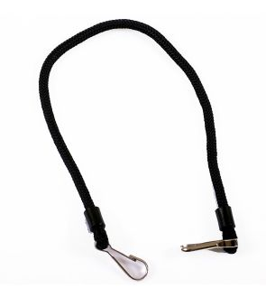

- Game card and pencil.

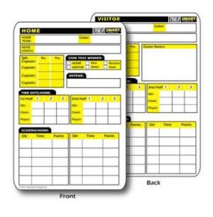
- Down indicator

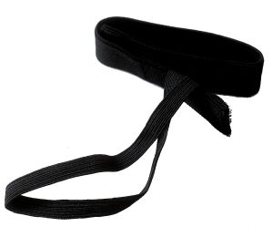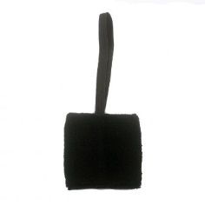

- Penalty flag

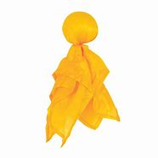

- Chain Clip (Head Linesman)
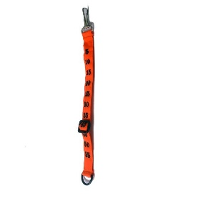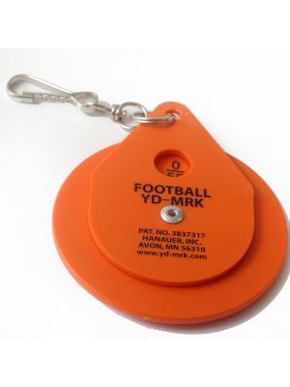

- Beanbag (Blue or White) 2 is recommended.

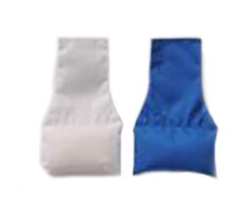
- Headsets for O2O’s. Various head sets are available.

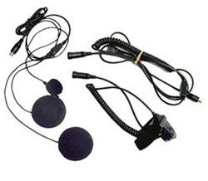

- O2O Midland radio (might be provided by Crew Chief)

- Coin

Chain Crew Uniform: The uniform for all chain assignments will be the same as your High School uniform with pants and except for an all-black t- shirt instead of a striped shirt. A SDCFOA logo on the t-shirt is acceptable if it is appropriate. You will need your chain clip but not your other accessories.
For your convenience, product and ordering information for six different suppliers is presented below. The SDCFOA does not specifically endorse any one supplier. Please note that there are special instructions required to take advantage of certain discounts.

Football - Cliff Keen Athletic | Football Referee Gear and Officials Equipment | Honigs | Hood Promotions  (858) 279-8600

Purchase Officials Supply | Football & Lacrosse Shirts – Smitty Officials Apparel (smittyapparel.com) | 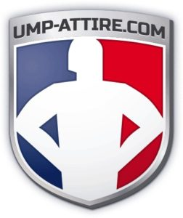  Ump-Attire

Assignments
This year you will start by working 2-3 Youth Football games on Saturday. Toward the end of the season, depending on various factors, you MAY get a Freshman or JV game. All game assignment contracts shall be published on the currently used web-based assignment program on pre-established dates. The SDCFOA uses a web-based scheduling system called ArbiterSports. Upon joining the SDCFOA, each member will be given an account to use ArbiterSports. The High School Assigner will instruct you on how to use it. It is recommended that all members electronically check their schedules daily in case of games changes or cancellations, site or time changes, etc. Members’ telephone answering devices and e-mail should also be monitored on a daily basis for any changes transmitted telephonic-ally or electronically.

If after an assignment has been assigned to you find you cannot work a game, call the appropriate Assignment Secretary ASAP. DO NOT try to reassign the game yourself. Also, DO NOT accept an assignment from another official.

Keep your availability open for the end of November and early December. We use Probationary officials as chain crew members for semi-final and final playoff games.

As a new member, you will deal with three assignment secretaries, one responsible for High School game assignments, and the other two splitting responsibility for Pop Warner and American Youth Football game assignments. The main objective of our training program is to prepare you to work on the field. There are several types of on-field assignments available to new members. These include scrimmages, youth football assignments, chain crew and clock operator assignments. Youth football provides great training opportunities for new officials.

Important: Immediately notify each Assignment Secretary of any changes in your availability or change of address, phone number or email.

Scrimmages
Scrimmages occur at the Varsity level in August. You will be assigned to one of the varsity crews or other veteran officials to work the scrimmages. The scrimmages are open to all officials and are great opportunities for new officials to get snaps. The more snaps you get the quicker you will become a proficient official. We recommend that new members try to work as many scrimmages as possible. The association, through ArbiterSports, will provide a schedule of scrimmages and which crews are working. New members should contact the referee of the respective crews to see if it is okay for them to attend. You may also check with the We recommend trying to attend a scrimmage with the fewest number of people assigned to maximize the number of snaps that you get.

My First Assignment
You will receive an email from ArbiterSports with the Subject “[ArbiterSports.com] You have new games from SDCFOA”. Accept the game as soon as possible. Games not accepted within 6 days of the day that they are published will be reassigned to another qualified member.
The assignment can be a scrimmage, youth football game, chain crew or clock operator. Contact the Crew Chief/Referee regarding arrival time, dressing accommodation, locker room location and where to park. If you have a Freshman or JV game, verify position with the Crew Chief/Referee.

Traveling to the game: Give yourself plenty of time to get to the game. Consider traffic and possible accidents on the way.

Attend the crew’s pre-game and post-game. Ask questions! The officials are there to help you In your training.

Should always arrive to the game casually dressed especially if you are a clock operator. Avoid flip flops, jeans with holes and t-shirts.

REMEMBER TO ACT PROFESSIONAL AND YOU WILL BE TREATED PROFESSIONALLY….AND MOST IMPORTANT ENJOY WHAT YOU ARE DOING.

Prepare for the game before you arrive to the game site. You will be working four-man mechanics. Review the mechanics, the position you’re working. The website provides handouts for the 4-man mechanics, position mechanics, chain crew and clock operator instructions. Remember you are a part of the CREW working the game…You will go onto and leave the field with the other Officials working the game.

Advancement
Attendances at the preseason clinics are a must. Generally, the assignment secretaries are there to observe and get an initial impression of your presence and ability. Accept as many games as possible. Do not turn games back. The more exposure you provide to certified members, the better your chances. Go to varsity games in your area. You are also encouraged to “shadow” crews during evening varsity games. Be there for the pregame, possibly work the chains, observe from the sidelines, and be present for the postgame wrap-up. Introduce yourself to the crew chief, sit in on the pregame, walk in with the crew and stand on the sidelines. Watch and study the moves of the flank officials and the umpire, then take what you learned to your Pop Warner game the next day. Do not miss meetings. Your instructor should be able to recognize you.

You could be working games right away on the youth games with high school games (Freshman and JV) later in the season and depending on your development. The experienced members of his crew during each game assignment evaluate each new official. The feedback from these evaluations determines the type and number of future assignments. The varsity schedule perhaps a varsity game late in season Varsity games come based on experience and typically may occur late into your second season.

Expectations and Tips for New Officials

Know the Mechanics!
Learn the mechanics and review them. The more you can think and visualize where you should be, the more natural it will seem during the game. Work hard to master your mechanics and see every play.

Preparation
Spend the proper amount of time reviewing the rulebook, casebook and mechanics manual so you’re prepared for game situations. The time you spend preparing to step on the field is vital to your success on the field.

Go Watch a Game
Go to a game and watch the officials. Watch how the crew communicates, the signals used and the positioning. Spend some time with them before and after the game.

Be on Time!
Arrive Early and Prepared. Don’t allow yourself to get in the habit of being the type of official who shows up right before game time. Get there early. Bring all your officiating gear. You never know what is going to happen.

Have Good Body Language
Body language will do you in quicker than a lack of knowledge. It is less a matter of what you say than how you say it. Your body language often speaks louder than words. Even a correct call will cast doubt in the minds of participants if you do not appear decisive. During dead-ball periods, do not stand with your arms folded or shoulders slumped, which gives the impression you’re bored or would rather be anywhere else.

Relax
You may have butterflies before your games (a lot of officials get them). As the game begins, take a deep breath and try to relax. Get into the flow of the game as soon as possible.

Concentrate
Do not allow yourself to be distracted by anything. Focus on the game and your fellow officials. It is easy sometimes to let your eyes wander to activities in the stands or benches. Concentrate on the game at hand. The action isn’t always where the ball is.

Forget Mistakes
All officials make mistakes. Do not make excuses admit your wrong and remind yourself to review why it happened after the game and then move on.

Ask Questions!
Ask experienced referees you work with to give you feedback. You do not have all the answers (none of us do). You cannot learn if you do not ask questions. Strive to get better every game.

Every Game Is a Big Game
Recognize the importance of all games you are working to the players, parents, and coaches.

Advancement
Advancement may come slower than you expect — but better a year late than a year too soon. You will not work varsity right away — and should not.

HAVE FUN!

Useful Links

The following are links to several of the web site you will utilize:

San Diego County Football Officials Association (sdcfoa.org)
Arbiter Sports - ArbiterSports

Hudl: We Help Teams and Athletes Win
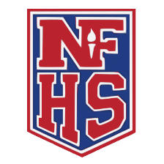
Football (nfhs.org)
Home - National Association of Sports Officials (naso.org)
Referee.com & Referee Magazine - Your Source For EVERYTHING Officiating

