Five Game Officials
NFHS Kickoff Mechanics
SDCFOA Pilot 2-24-21

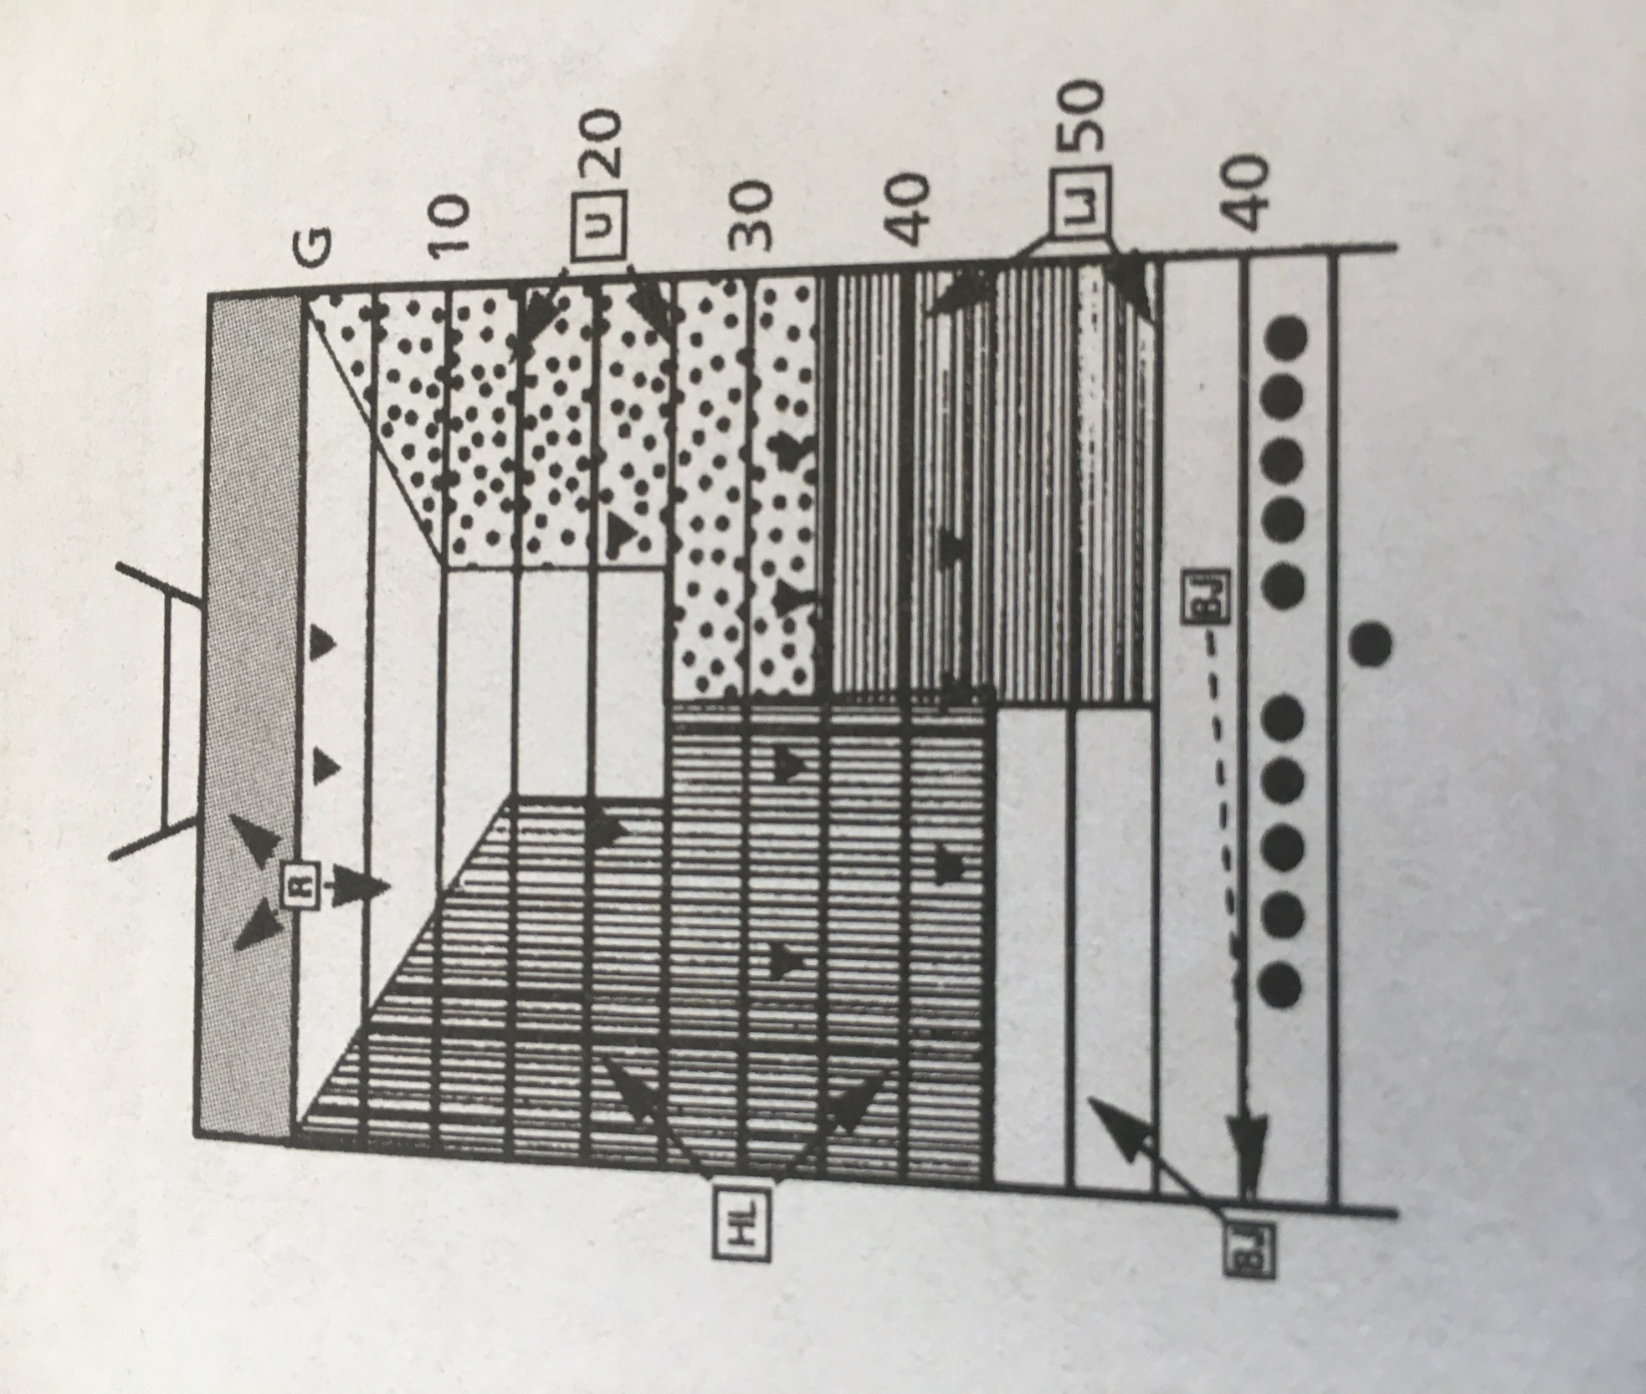

REFEREE
Before kick:
- Position: R’s goal yard line on the head linesman's side between the center cf the field and hash marks.
- Count R players.
- Check positions of other game officials.
- After ready signs have been received from other game officials, declare the ball ready for play and sound whistle and verify that at least four K players must be on each side of the kicker until the ball is kicked.
- If short free kick is anticipated:
  - Take position near R's 10-yard line.
  - Be alert to assist other game officials.
After kick:
- Kick down the middle:
  - Signal game clock to start (S #2) when kick is touched other than first touching by K.
  - Pick up runner and follow until releasing to covering official.
- Deep kick:
  - While standing on goal line, rule on touchback.
  - If kick is caught inside 5-yard line and player is downed in end zone, or ball goes out of bounds there, rule on whether player's momentum took him/her into end zone and mark spot of catch with bean bag.
- Kick outside opposite hash mark:
  - Move cautiously with play.
  - Observe action of other players in vicinity of runner.
  - Serve as clean-up behind, to side of, and around runner.
- Mark out-of-bounds spot if kick goes out-of-bounds in your •area:
  - Drop penalty marker if untouched inbounds by R.
UMPIRE
Before kick:
- Be certain coaches, players, substitutions and other individuals are in proper locations.
- Position: On Rs 20-yard line outside sideline opposite head linesman.
- Count R players.
- Hold arm above head to indicate you are ready.
- If short kick is anticipated, position on R's free-kick line.
  - Be alert for first touching by K or kick which does not cross R's free kick line.
  - Hold bean bag to mark first touching by K.
  - Observe legality of blocks and action away from the ball.
After kick:
- Kick to your side:
  - Signal game clock to start when kick is legally touched, only if ball is even or upfield from you.
  - Pick up runner and follow along sideline
  - When ball becomes dead, sound whistle and give time-out signal (S #3).
- When kickoff goes outside opposite hash mark:
  - Move cautiously with play along sideline.
  - Observe action of other players in vicinity of runner.
  - Serve as clean-up behind, to side of, and around runner.
- Maintain position enabling coverage of your sideline at all times.
- Mark out-of-bounds spot if kick goes out of bounds in your area:
  - Drop penalty marker if untouched inbounds by R.

HEAD LINESMAN
Before kick:
- Be certain coaches, players, substitutes and other individuals are in proper location.
- Position: R's 30-yard line outside the same sideline as the line-togain indicator.
- Count R players.
- Hold arm above head to indicate you are ready.
- If short free-kick is anticipated:
  - Position on R s free-kick line.
  - Be alert for first touching by K or kick which does not cross R's free-kick line. Hold bean bag to mark first touching by K.
After kick:
- Kick to your side:
  - Signal game clock to start (S #2) when the kick is legally touched, only if ball is even or upfield from you.
  - Pick up runner and follow along sideline.
  - When ball becomes dead, sound whistle and give time-out signal.
- Be alert for first touching by K, and mark spot with bean bag.
- Mark spot where kick goes out-of-bounds on your side of field:
  - Drop penalty marker if untouched inbounds by R.
- Maintain position enabling coverage of your sideline at all times.
- Observe legality of blocks and action away from the ball when you are not covering the runner.
- Kick to opposite side of field:
  - Move cautiously with play along sideline.
  - Observe action of other players in vicinity of runner.
LINE JUDGE
Before kick:
- Be certain coaches, players, substitutes and other individuals are in proper locations.
- Position: Rs free-kick line, outside sideline opposite head linesman.
- Temporarily move to 9-yard marks, then count K players and identify the free-kick line for the receiving team.
- Hold arm above head to indicate you are ready.
- Watch for any infractions involving R's free-kick line.
- If short free-kick is anticipated:
  - Position on KS free-kick line.
  - Be alert for first touching by K or kick which does not cross R's free-kick line. Hold bean bag to mark first touching by K.
After kick:
- Be alert for first touching by K - mark spot with bean bag.
- Watch initial blocks in your area.
- If ball becomes dead in your area, sound whistle and give time-out signal.
- Mark spot where kick goes out of bounds on your side of field with penalty marker if untouched inbounds by R.
- After ball has gone downfield, move deliberately along sideline in that direction while watching for fouls away from ball. Cover 15 yards down sideline.
- Be in position to take over coverage of runner in your area on long return.
- Kick to opposite side of field:
  - Move cautiously with play along sidelines.
  - Observe action of other players in vicinity of runner.

BACK JUDGE
Before kick:
- Take charge of ball.
- Position: K's free-kick line outside sideline to monitor bench area and assist kicking team in getting into position.
- Move on field to kicker and after checking legality of kicking tee, hand kicker ball, point out referee and instruct kicker to wait for referee's signal before kicking. If the kicker is not ready place the ball on the ground and proceed to the sideline.
- Count K players.
- Move to a position just outside the sideline on K's free-kick line on the line-to-gain indicator side.
- Be certain coaches, players, substitutes and other individuals are in proper locations and no K plaers, with the exception of the kicker, may be more than 5 yards behind the kicking team's free-kick line. 7. Hold arm above head to indicate you are ready.
- If ball falls or blows off tee, sound whistle to prevent action. Move to kicker to give instructions.
- Watch for any infractions involving K's free-kick line.
- If there is a foul to be administered on the free-kick, give final signal and administer penalty.
- Time play clock
After kick:
- Be alert for first touching by K—mark spot with bean bag.
- Be alert for a kick which does not cross R's free-kick line.
- If there is a penalty for a foul before kick ends requiring re-kick, administer penalty and place ball ready.
- Mark out-of-bounds spot if kick goes out of bounds in your area with penalty marker if untouched inbounds by R.
- Watch initial blocks by players near R's free-kick line and action against kicker and holder. Cover to opposite 45-yard line.
- After ball has gone downfield, move to the center of the field. Move downfield no more than 10-15 yards while maintaining inside-out coverage. Take responsibility for K’s goal line.
- Be in position to take over coverage of runner in your area on long return.
- Observe legality of blocks and action away from ball.
ALL GAME OFFICIALS
- Covering official(s) signal game clock to start (S #2) when kick is touched, other than first touching by K.
- Kick out of bounds between goal lines:
  - Sound whistle.
  - Give time-out signal (S #3) twice and mark spot.
  - Determine if R had touched.
  - Toss penalty marker if R did not touch the ball.
- Maintain position on sideline at all times except for referee and back judge.
- Sound whistle when ball becomes dead in your area and give time-out signal.
- Carry bean bag in hand.
- Free kick following safety:
  - Each game official assumes same relative position and has same duties as on kickoff.
  - Ball put in play by drop kick, place kick, or punt.

