Five Game Officials
NFHS Kickoff Mechanics
SDCFOA Pilot 2-24-21

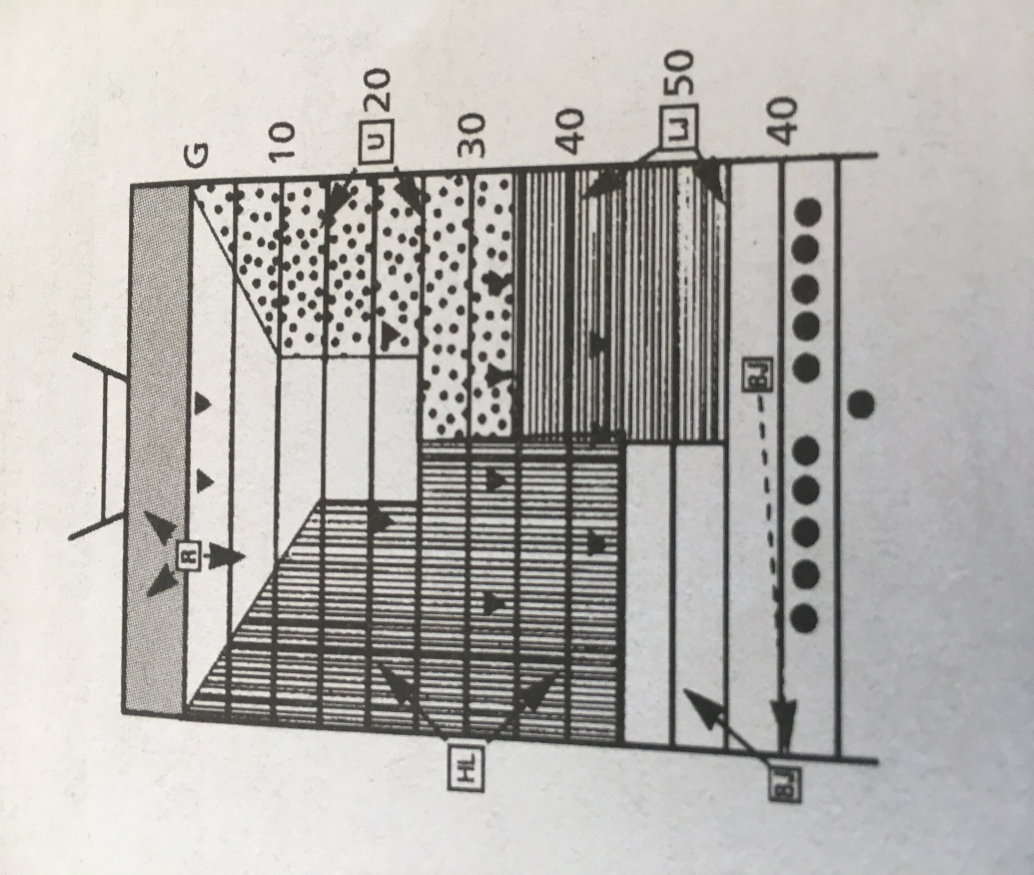

REFEREE
Before kick:
- Position: R’s goal yard line on the head linesman's side between the center of the field and hash marks.
- Count R players and confirm with U and H.
- Check positions of other game officials.
- After ready signs have been received from other game officials, declare the ball ready for play, sound whistle and verify at least four K players are on each side of the kicker when the ball is kicked.
- If short free kick is anticipated:
  - Take position near R's 10-yard line if there is no R player deep
  - Be alert to assist other game officials and be aware of game clock
After kick:
- Signal game clock to start when kick is legally touched in your area in the field of play
- Kick down the middle:
  - Pick up runner and follow until releasing to covering official
  - Observe action with an inside-out view of blocks in front of the runner
  - Serve as clean-up behind, to side of, and around runner
- Deep kick:
  - While standing on goal line, rule on touchback
  - If kick is caught inside 5-yard line and player is downed in end zone, rule on whether the momentum rule applies. If momentum applies, mark spot of catch with bean bag.
- Kick outside opposite hash mark:
  - Move cautiously with play
  - Observe action of other players in vicinity of runner
  - Serve as clean-up behind, to side of, and around runner
- Mark out-of-bounds spot if kick goes out-of-bounds in your area. Be sure to communicate with U or H before making ruling.
  - Drop penalty marker if untouched inbounds by R
  - Be prepared to rule at goal line pylon
UMPIRE
Before kick:
- Be certain coaches, players, substitutions and other individuals are in proper locations.
- Position: On R's 20-yard line outside sideline opposite head linesman. If K's free-kick line is relocated due to penalty or the situation dictates, U may take position anywhere from the R-10 to the R-30, preferably 10 yards downfield of H.
- Count R players and confirm with Referee.
- Hold arm above head to indicate you are ready.
- If short kick is anticipated, position on R's free-kick line.
  - Be alert for first touching by K or kick which does not cross R's free-kick line
  - Watch for any infractions involving R's free-kick line
  - Hold bean bag to mark first touching by K
  - Observe legality of blocks and action away from the ball
After kick:
- Kick to your side:
  - Signal game clock to start when kick is legally touched in your area
  - Remain stationary for optimal viewing of blocks between the R-20 and R-30
  - Pick up runner and follow along sideline. Allow the action to pass before moving upfield and trail the play by approximately 10 yards.
  - Responsibility for progress of the runner from the R goal line to the R-35-yard line
  - When ball becomes dead, sound whistle and give time-out signal. Obtain the offense’s game ball from sideline if applicable.
  - If the ball is kicked outside the numbers behind your starting position, turn and officiate the ball, returner, and sideline
- Kick to opposite side of field:
  - Move cautiously with play along sideline
  - Observe action of other players in vicinity of runner
  - Serve as clean-up behind, to side of, and around runner
  - Use cross field mechanics when appropriate to assist the H with progress spot
- Maintain position enabling coverage of your sideline at all times.
- Observe legality of blocks and action away from the ball when you are not covering the runner
- Mark out-of-bounds spot if kick goes out of bounds in your area:
  - Drop penalty marker if untouched inbounds by R
  - If the goal line pylon is threatened, communicate with Referee before making a ruling

HEAD LINESMAN
Before kick:
- Take charge of getting your team on the field promptly.
- Be certain coaches, players, substitutes and other individuals are in proper location.
- Position: R's 30-yard line outside the same sideline as the line-to gain indicator. If K's free-kick line is relocated due to penalty or the situation dictates, H may take position anywhere from the R-20 to R-40, preferably 10 yards upfield of U.
- Count R players and confirm with Referee.
- Hold arm above head to indicate you are ready.
- If short free-kick is anticipated, position on R's free-kick line:
  - Be alert for first touching by K or kick which does not cross R's free-kick line
  - Watch for any infractions involving R's free-kick line
  - Hold bean bag to mark first touching by K
  - Observe legality of blocks and action away from the ball
After kick:
- Kick to your side:
- Signal game clock to start when the kick is legally touched in your area
- Remain stationary for optimal viewing of blocks between the R-20 and R-30
- Pick up runner and follow along sideline
- Responsibility for progress of the runner from the goal line to goal line
- When ball becomes dead, sound whistle and give time-out signal
- If the ball is kicked outside the numbers behind your starting position, turn and officiate the ball, returner, and sideline
- Kick to opposite side of field:
  - Move cautiously with play along sideline
  - Observe action of other players in vicinity of runner.
  - Serve as clean-up behind, to side of, and around runner
  - Use cross field mechanics when appropriate to assist the U or L with progress spot
- Maintain position enabling coverage of your sideline at all times.
- Observe legality of blocks and action away from the ball when you are not covering the runner.
- Mark spot where kick goes out-of-bounds on your side of field:
  - Drop penalty marker if untouched inbounds by R
  - If applicable, obtain the foul decision from head coach and communicate to Referee
  - If the goal line pylon is threatened, communicate with Referee before making a ruling

LINE JUDGE
Before kick:
- Take charge of getting your team on the field promptly.
- Be certain coaches, players, substitutes and other individuals are in proper locations.
- Position: R's free-kick line, outside sideline opposite head linesman.
- Temporarily move to 9-yard marks, then count K players and confirm with Back Judge; identify the R free-kick line.
- Hold arm above head to indicate you are ready.
- Hold bean bag to mark first touching by K.
- Watch for any infractions involving R's free-kick line.
- If short free-kick is anticipated:
  - Position on K's free-kick line
  - Be alert for first touching by K or kick which does not cross R's free-kick line
  - Watch for any infractions involving K's free-kick line
  - Hold bean bag to mark first touching by K
  - Observe legality of K’s blocks within the neutral zone
  - Rule on illegal pop-up kicks
After kick:
- Be alert for first touching by K - mark spot with bean bag.
- Move downfield approximately 5-10 yards after the ball is kicked, while staying on the sideline, to maintain a 20-25 yard cushion between the Umpire.
- As the return starts, use a reverse or "fade" mechanic allowing for a front side, outside-in view of blocks in front of the runner.
- Watch initial blocks in your area.
  - If the ball is kicked outside the numbers on your side of the field behind the U's starting position, pick up first line blocks in front of the U.
- Signal game clock to start when kick is touched in your area other than first touching by K.
- If ball becomes dead in your area, sound whistle and give time-out signal.
- Mark spot where kick goes out of bounds on your side of field with penalty marker if untouched inbounds by R.
  - If applicable, obtain the foul decision from head coach and communicate to Referee
- Responsible for progress of the runner beyond the R-35-yard line to K goal line. Note: It is acceptable to officiate progress from in front of the runner, while maintaining cushion with the U and keeping goal line responsibility.
- Be in position to take over coverage of runner in your area on long return.
- Kick to opposite side of field:
  - Move cautiously with play along sidelines.
  - Observe action of other players in vicinity of runner
  - Serve as clean-up behind the action
  - Takeover spot from H so H can setup chains/box

BACK JUDGE
Before kick:
- Take charge of ball.
- Position: K's free-kick line outside sideline to monitor bench area and assist kicking team in getting into position.
- Check legality of kicking tee and ball, hand kicker ball, point out referee and instruct kicker to wait for referee's signal before kicking. If the kicker is not ready place the ball on the ground and proceed to the sideline.
- Count K players and confirm with Line Judge.
- Use preventative officiating by initially having all K players within 5 yards of K’s free-kick line, and at least 4 on each side of kicker
- Move to a position just outside the sideline on K's free-kick line on the line-to-gain indicator side.
- Be certain coaches, players, substitutes and other individuals are in proper locations and no K players, with the exception of the kicker, may be more than 5 yards behind the kicking team's free-kick line.
- Hold arm above head to indicate you are ready.
- If ball falls or blows off tee, sound whistle to prevent action. Move to kicker to give instructions.
- Watch for any infractions involving K's free-kick line.
- Time play clock
- If short free-kick is anticipated:
  - Position on K's free-kick line.
  - Be alert for first touching by K or kick which does not cross R's free-kick line.
  - Hold bean bag to mark first touching by K.
  - Watch for any infractions involving K's free-kick and 5-yd restraining lines
  - Observe legality of K’s blocks within the neutral zone
  - Rule on illegal pop-up kicks
After kick:
- Be alert for first touching by K and mark spot with bean bag.
- Be alert for a kick which does not cross R's free-kick line.
- If there is a penalty for a foul requiring re-kick, administer penalty and place ball ready.
- Mark spot where kick goes out of bounds in your area with penalty marker if untouched inbounds by R.
- Watch initial blocks by players near R's free-kick line and action against kicker and holder (if used). Cover to opposite 45-yard line.
- After ball has gone downfield, move quickly to the center of the field on or near R's restraining line.
  - Maintain cushion of approximately 25 yards from the runner
  - Maintain an inside-out view of action during the return
  - As the play dictates, shading to one side of the field is acceptable to ensure adequate coverage of the return
  - If the ball is kicked outside the numbers behind the H’s starting position, pick up first line blocks in front of the H
- Responsible for K’s goal line.
- Be in position to take over coverage of runner in your area on long return.
- Observe legality of blocks and action away from ball.
- Ensure kicking tee is removed and kicking ball is returned to sideline.

ALL GAME OFFICIALS
- Ensure each team has 11 players on the field before the kick.
- Hustle to positions and get teams on the field promptly after a score.
- Covering official(s) signal game clock to start when kick is touched, other than first touching by K.
- Kick out of bounds between goal lines:
  - Sound whistle.
  - Give time-out signal twice and mark spot.
  - Determine if R had touched.
  - Toss penalty marker if R did not touch the ball.
- Maintain position on sideline at all times except for referee.
- Sound whistle when ball becomes dead in your area and give time-out signal
- Free kick following safety:
  - Each game official assumes same relative position and has same duties as on kickoff.
  - Ball may be put in play by drop kick, place kick, or punt.

