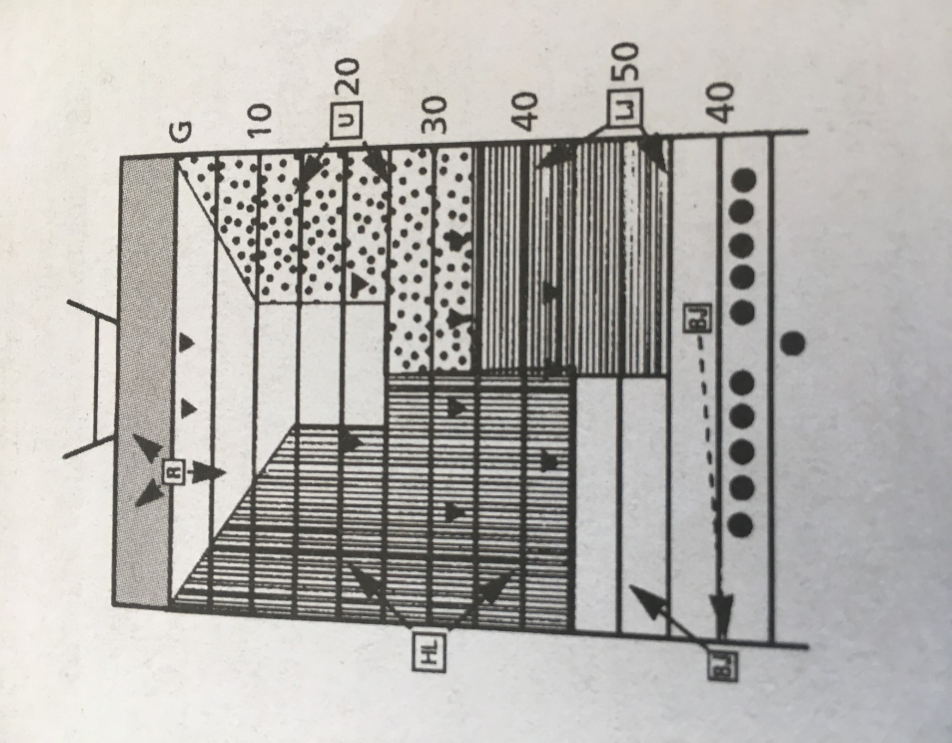
Free Kick Diagram – 5-Man Mechanics

